Software Requirements Specification
For
E-Commerce site for
Visually impaired people
Prepared by Abhin P T and Sona Rosa Babloo
DEPARTMENT OF COMPUTER SCIENCE, CUSAT
15/02/2023
Table of Contents

1. Introduction 1
1.1 Purpose 1
1.2 Need Motivation 1
2. Overall Description 1
2.1 Product Features 1
2.2 User Classes and Characteristics 2
2.3 User functionalities 3
2.4 Technologies used 3
2.5 Wireframes 4

Introduction
We would like to design an e-commerce platform for individuals with disabilities that aims to empower them with the choice of services they need.
The site will be web-based and accessible through the internet, offering a clear and user–friendly interface for seeming less navigation

Purpose
The goal of this project is to empower individuals with disabilities and give them the opportunity to use our platform independently, based on their abilities. We also prioritize privacy by offering a secure and private environment for individuals with disabilities to make purchases without the need for assistance from others.

Need Motivation
Today, there are many individuals with disabilities who find it challenging to complete daily tasks independently. They often require assistance from others.

However, with the advancements in technology, people with disabilities are often excluded from using it as they lack of accessibility and consideration for their needs in the design of these technologies.
Our web application is designed to empower and encourage them, and we believe that this makes a small step towards creating a more inclusive society where technology is accessible to everyone.

Overall Description

Product Features
- Accessibility: We plan to make the website accessible for users with various disabilities by incorporating features such as screen reader compatibility for the visually impaired, keyboard navigation for those users, and adjustable text size for users with visual or cognitive impairments.
- User-friendly design: Our goal is to design the website with a clean and simple layout, intuitive navigation, and language that is easy to understand for all users.
- Product descriptions: To help users make informed purchasing decisions, we plan to provide detailed and clear product descriptions that include information on size, weight, and materials.
- Large images: To assist users with visual impairments, we will display large images of products on the website.
- Search and filter options: To make it easier for users to find what they are looking for, we plan to provide search and filter options based on criteria such as price, brand, and category.
- Reviews and ratings: We encourage users to leave reviews and ratings for products to help others make informed purchasing decisions.
- Customer support: To ensure that users can get the help they need, we plan to offer customer support through multiple channels, such as email, phone, and live chat.
- Easy checkout process: Our aim is to make the checkout process simple, fast, and secure, with options for saved payment methods and easy order tracking.
- Screen reader compatibility: Make sure the website is fully accessible to screen reader software, which allows blind users to hear the content of the website through a synthesized voice.
- Keyboard navigation: Allow users to navigate the website using only their keyboard, since some blind users may not be able to use a mouse or touchpad.
- High-contrast mode: Include a high-contrast mode option, which can help make the website more visually accessible to users with low vision.
- Large font sizes: Provide the option to increase font sizes to make it easier for users to read the text on the website.
- Alternative text for images: Provide alt text for all images on the website, which allows screen reader software to read a description of the image to the user.
- Audio descriptions: Consider providing audio descriptions for products, which can help blind users get a better sense of what they're purchasing.
- Clear and concise language: Use clear and concise language on the website, avoiding complex jargon or unnecessarily verbose descriptions that can be difficult for users to understand.
- Accessible payment options: Ensure that payment options are fully accessible and can be used by users who may have difficulty with traditional payment methods.

User Classes and Characteristics
1. Users with total blindness: These users have no vision at all and rely on screen readers or other assistive technology to navigate the web. They may use a keyboard to navigate the site rather than a mouse and may need clear and concise descriptions of products and services to make informed purchasing decisions.

2. Users with low vision: These users have some level of vision but may require larger text, high contrast, and clear, easy-to-read fonts. They may also benefit from the ability to zoom in on images and text and may need to adjust the color and brightness of the screen.

3. Users with color blindness: These users may have difficulty distinguishing between certain colors, such as red and green. The site should be designed with color blindness in mind, using high-contrast colors and avoiding color schemes that rely on color alone to convey meaning.

4. Users with mobility impairments: These users may have difficulty using a mouse or touchpad, and may need keyboard shortcuts or other alternative navigation methods to browse the site.

5. Users with cognitive impairments: These users may have difficulty processing complex information, so the site should be designed with simplicity and clarity in mind. This could include clear and concise product descriptions, simple navigation, and limited distractions.

User functionalities
Admin user functionalities:
- Add new products to the e-commerce site.
- Update existing products on the e-commerce site.
- Normalize the rates of the products on the e-commerce site.
- Manage customer accounts and orders on the e-commerce site.
- Create and manage promotions and discounts for the products on the e-commerce site.
- View and respond to customer feedback and inquiries on the e-commerce site.
- View sales reports and analytics to monitor the performance of the e-commerce site.

Customer user functionalities:
- Log into the e-commerce site, create an account, and access the site's features.
- Browse through the products on the e-commerce site.
- Add desired products to the cart on the e-commerce site.
- Create a wish list on the e-commerce site.
- Customize the interface of the e-commerce site according to their requirements.
- Use the accessibility features of the e-commerce site to make it more user-friendly for differently abled customers.
- Leave ratings and reviews on the products on the e-commerce site.
- View their order history on the e-commerce site.
- Use the search and filter options to find products quickly and efficiently on the e-commerce site.
- Share product details and recommendations with friends and family through social media platforms from the e-commerce site.
- Receive notifications on new product addition and new discount sales available as of now.

Technologies used
- Our project is an e-commerce website that will be developed using React.js for the front end and Node.js for the back end. We have chosen to implement this website using the
M E R N architecture, which stands for Mongo DB, Express, React, and Node – are the four key technologies involved in the development process.
- Mongo DB — document database
- Express(.js) — Node.js web framework
- React(.js) — a client-side JavaScript framework
- Node(.js) — the premier JavaScript web server
The MERN architecture allows you to easily construct a three-tier architecture (front end, back end, database) entirely using JavaScript and JSON. Most importantly we implement these using
Agile development methodologies such as Scrum to ensure that the project is delivered on time and meets the needs of our clients and end-users.
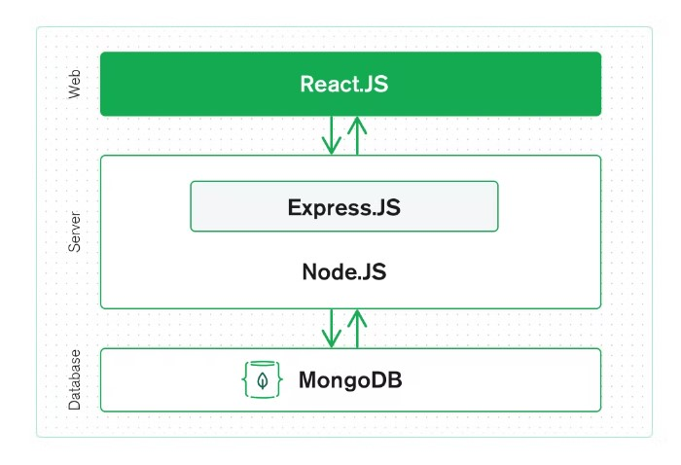

Wireframes
  - Main page
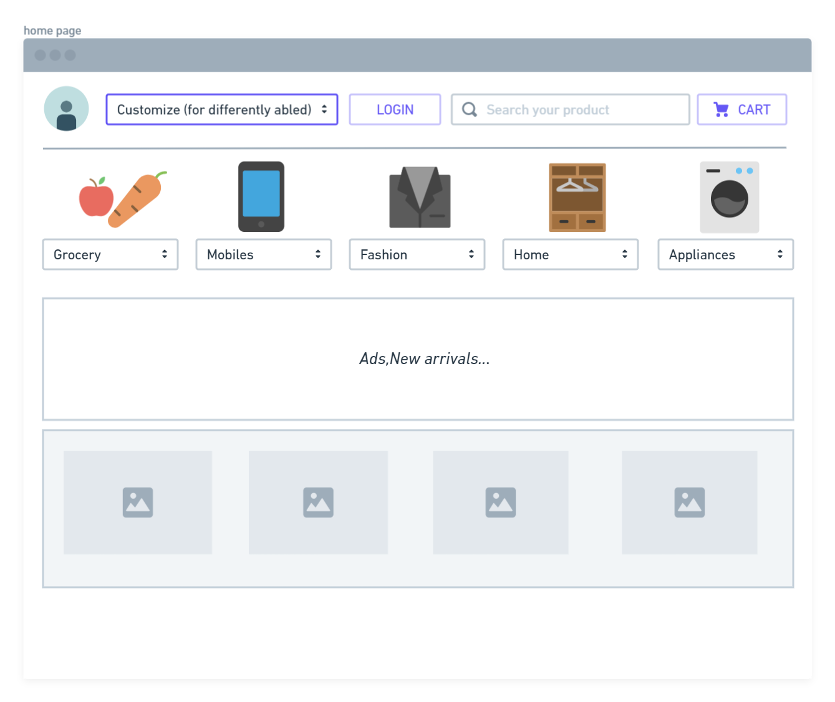

  - Login Page
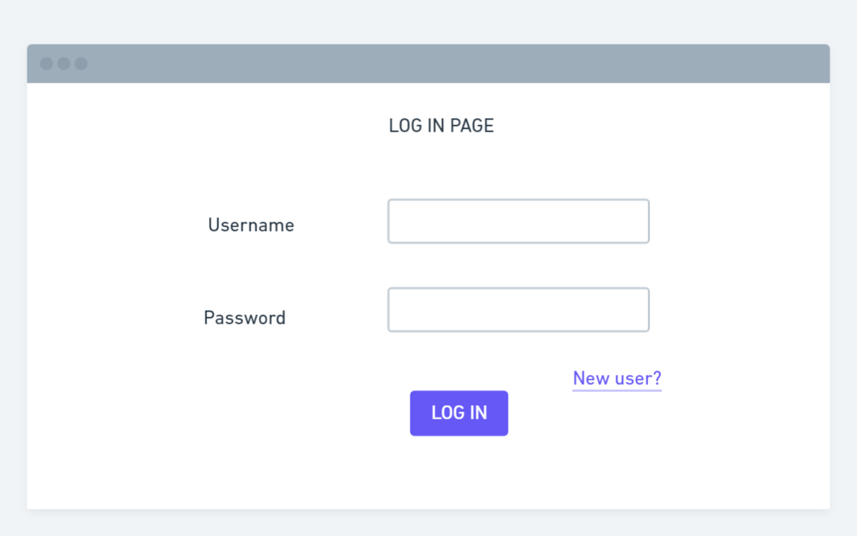
  - Sign up Page
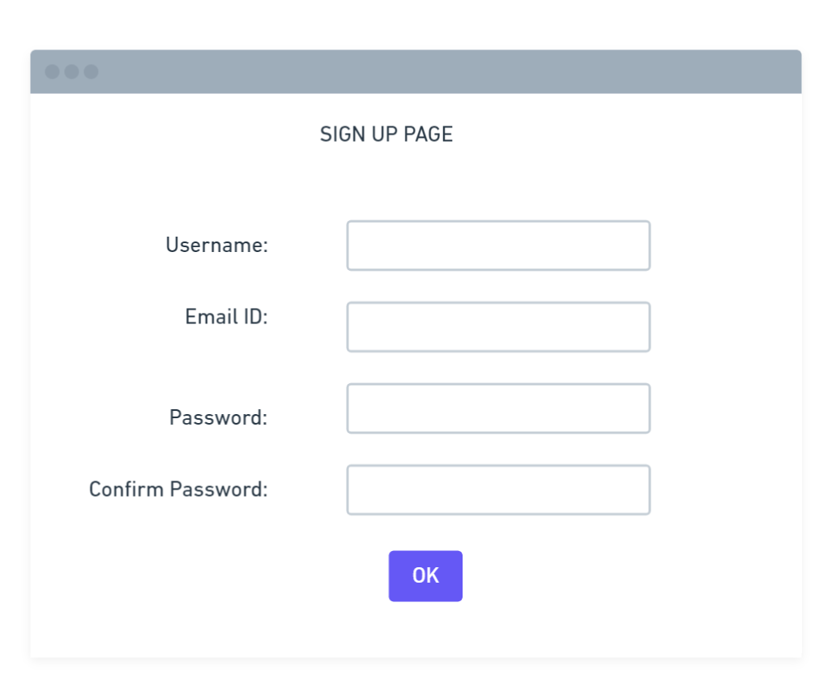

  - Product details Page
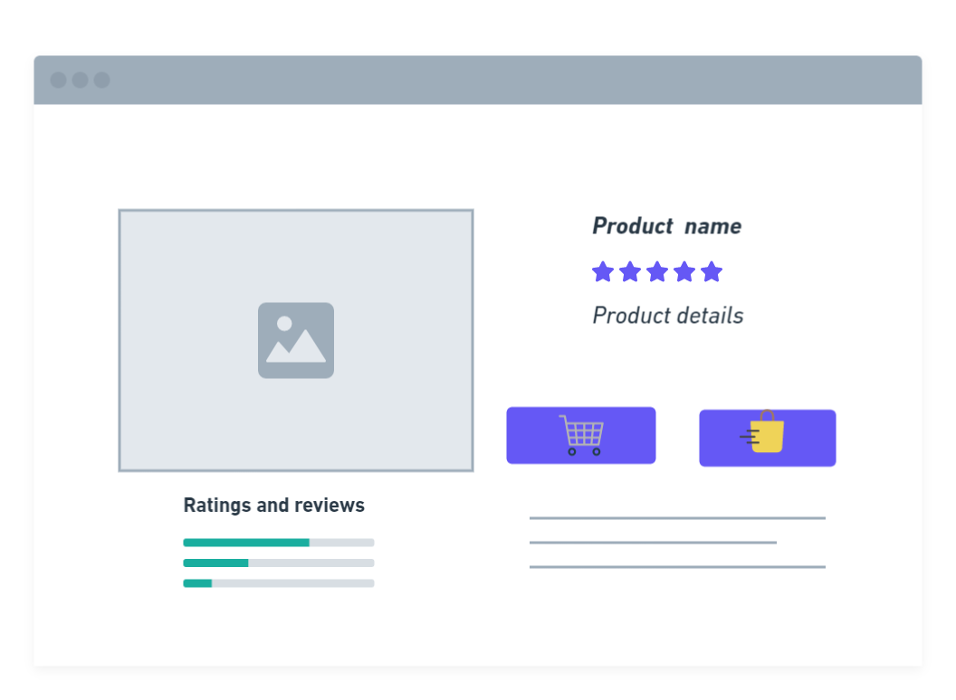
  - Add to Cart page
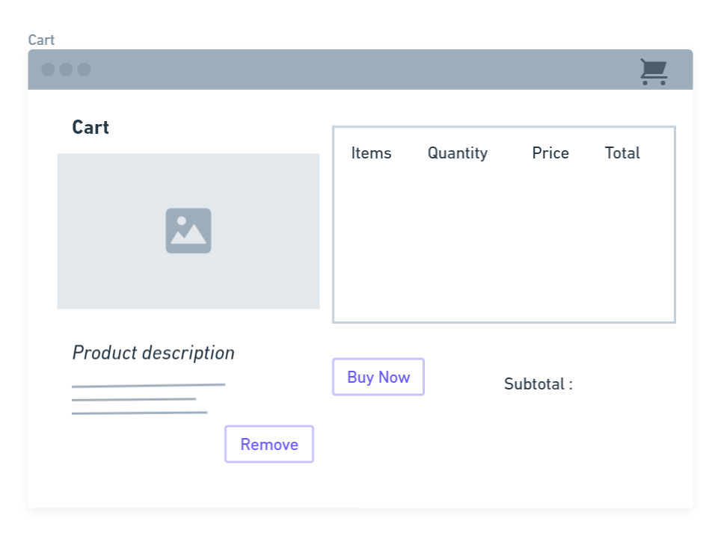

Wireframes-User Workflow

